NOR

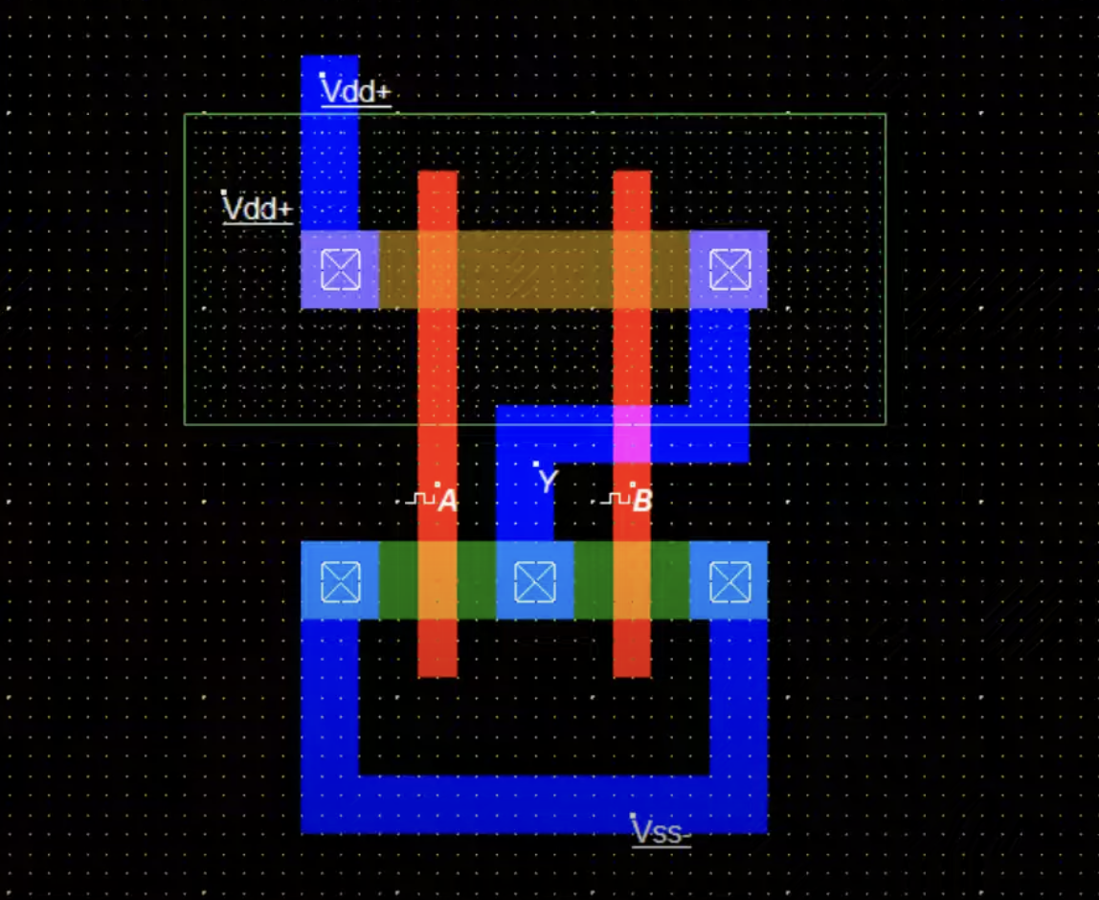

NAND

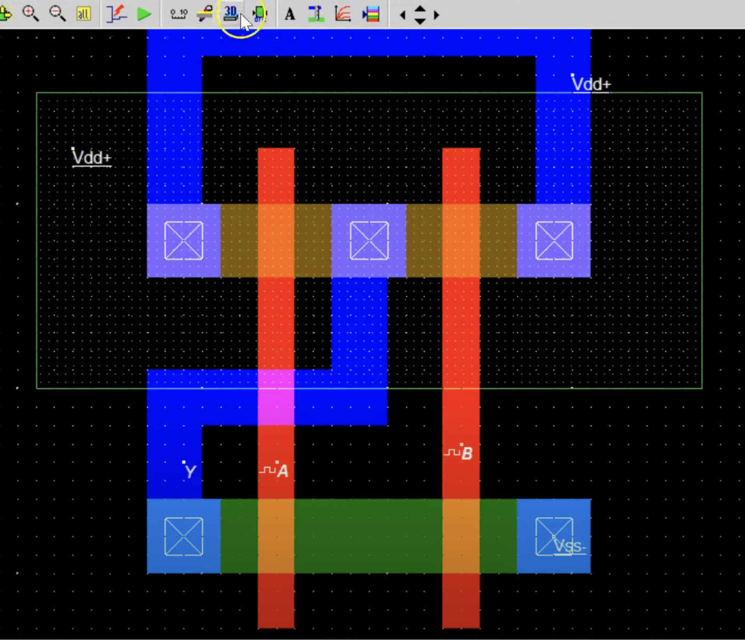

HALF ADDER

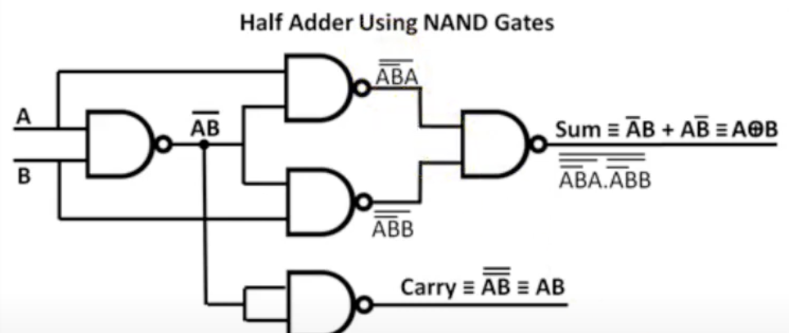

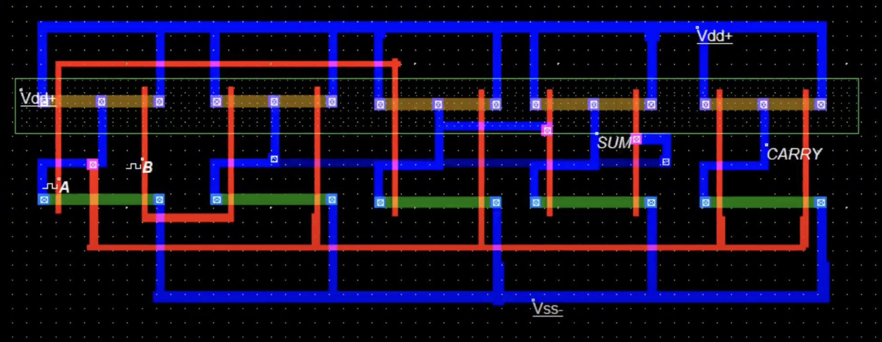

2:1 MUX

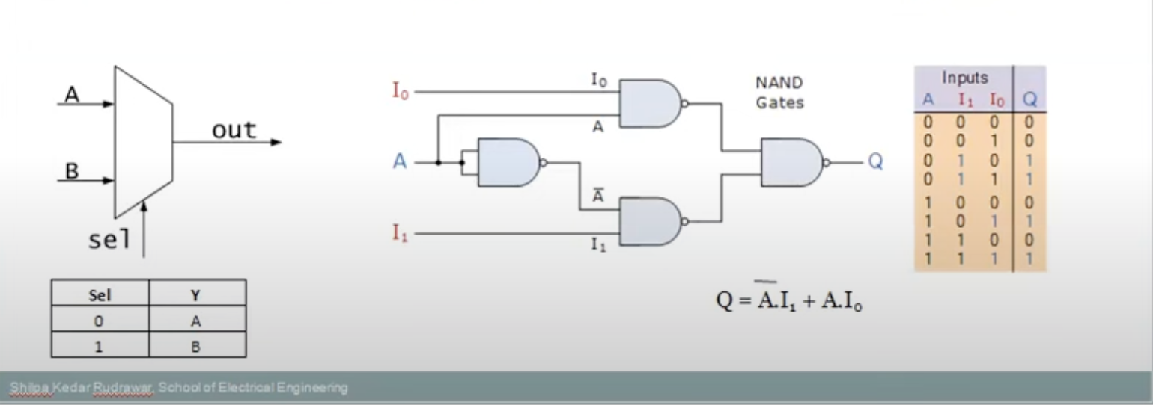

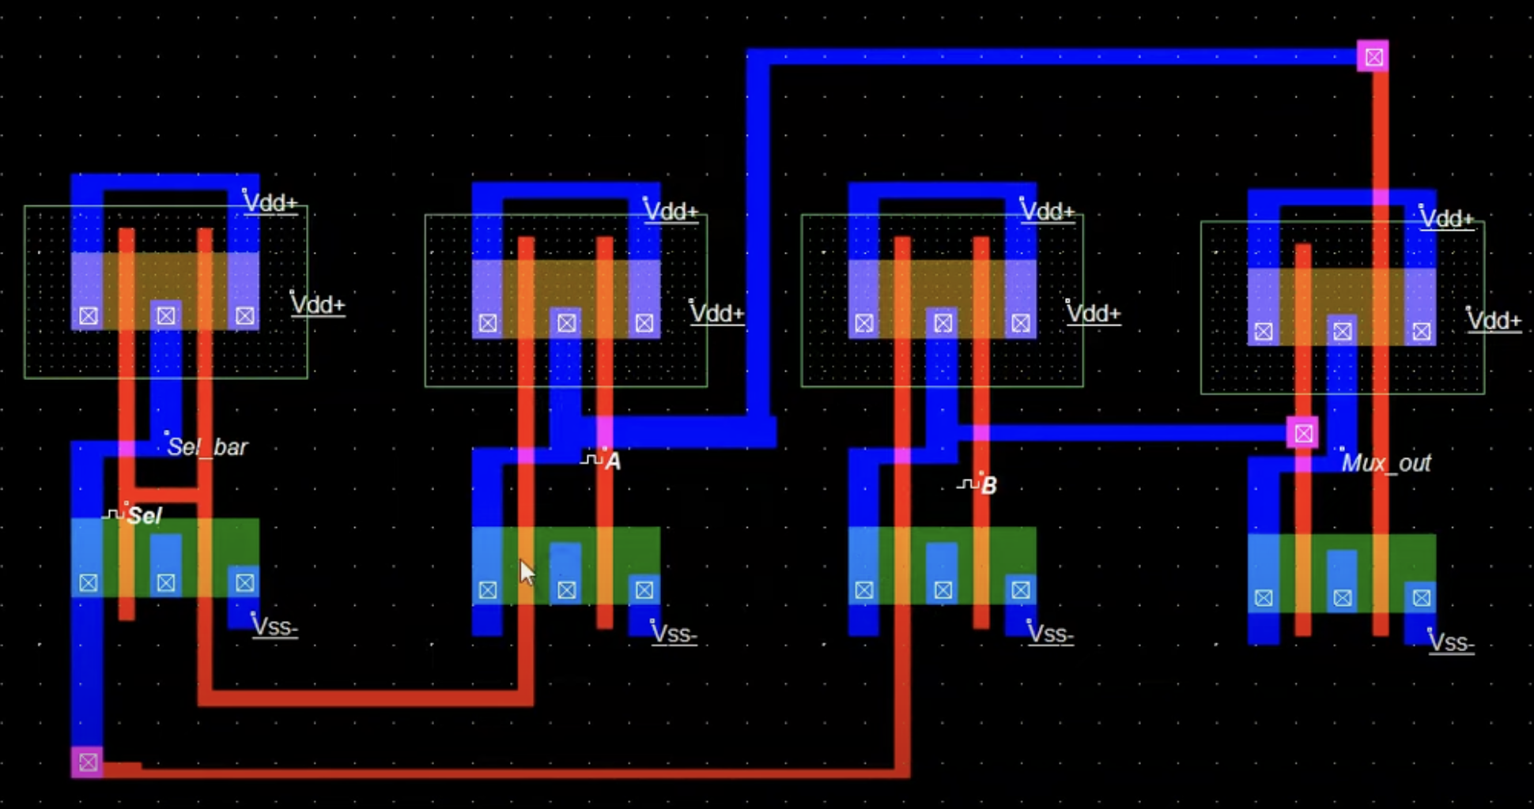

1. *--------------HALF ADDER---------------------*
2. **library** IEEE;
3. **use** IEEE.STD_LOGIC_1164.**ALL**;
5. **entity** HalfAdder **is**
6. **Port** ( A, B : **in** STD_LOGIC;
7. Sum, Carry : **out** STD_LOGIC);
8. **end** HalfAdder;
10. **architecture** Behavioral **of** HalfAdder **is**
11. **begin**
12. **process**(A, B)
13. **begin**
14. Sum <= A XOR B;    *-- XOR gives the sum bit*
15. Carry <= A AND B;  *-- AND gives the carry bit*
16. **end** **process**;
17. **end** Behavioral;



22. *------------------ALU--------------------------*
23. **library** IEEE;
24. **use** IEEE.STD_LOGIC_1164.**ALL**;
25. **use** IEEE.STD_LOGIC_unsigned.**ALL**;
27. **entity** FourBitALU **is**
28. **Port** ( A, B : **in** STD_LOGIC_VECTOR(3 **downto** 0);
29. opcode : **in** STD_LOGIC_VECTOR(2 **downto** 0);
30. result : **out** STD_LOGIC_VECTOR(3 **downto** 0));
31. **end** FourBitALU;
33. **architecture** Behavioral **of** FourBitALU **is**
34. **signal** temp_result : STD_LOGIC_VECTOR(4 **downto** 0); *-- To handle overflow*
35. **begin**
37. **process**(A, B, opcode)
38. **begin**
39. **case** opcode **is**
40. **when** "000" => *-- ADD*
41. temp_result <= ('0' & A) + ('0' & B);
42. **when** "001" => *-- SUBTRACT*
43. temp_result <= ('0' & A) - ('0' & B);
44. **when** "010" => *-- AND*
45. temp_result <= A AND B;
46. **when** "011" => *-- OR*
47. temp_result <= A OR B;
48. **when** "100" => *-- XOR*
49. temp_result <= A XOR B;
50. **when** "101" => *-- NAND*
51. temp_result <= A NAND B;
52. **when** "110" => *-- NOR*
53. temp_result <= A NOR B;
54. **when** "111" => *-- NOT*
55. temp_result <= not A;
56. **when** **others** =>
57. temp_result <= (**others** => '0');
58. **end** **case**;
60. result <= temp_result(3 **downto** 0); *-- Extract the 4-bit result*
61. **end** **process**;
63. **end** Behavioral;





70. *-------------------COUNTER--------------------------*
71. **library** IEEE;
72. **use** IEEE.STD_LOGIC_1164.**ALL**;
73. **use** IEEE.STD_LOGIC_unsigned.**ALL**;
75. **entity** UpDownCounter **is**
76. **Port** ( clk : **in** STD_LOGIC;
77. rst : **in** STD_LOGIC;
78. up_down : **in** STD_LOGIC;
79. count : **out** STD_LOGIC_VECTOR(3 **downto** 0));
80. **end** UpDownCounter;
82. **architecture** Behavioral **of** UpDownCounter **is**
83. **signal** counter : STD_LOGIC_VECTOR(3 **downto** 0) := "0000";
84. **begin**
86. **process**(clk, rst)
87. **begin**
88. **if** rst = '1' **then**
89. counter <= "0000"; *-- Reset the counter to 0*
90. **elsif** rising_edge(clk) **then**
91. **if** up_down = '1' **then**
92. *-- Up counter*
93. counter <= counter + 1;
94. **else**
95. *-- Down counter*
96. counter <= counter - 1;
97. **end** **if**;
98. **end** **if**;
99. **end** **process**;
101. count <= counter;
103. **end** Behavioral;





110. *--------------Seven Segment------------------*
111. **library** IEEE;
112. **use** IEEE.STD_LOGIC_1164.**ALL**;
113. **use** IEEE.STD_LOGIC_unsigned.**ALL**;
115. **entity** SevenSegmentDisplay **is**
116. **Port** ( clk : **in** STD_LOGIC;
117. rst : **in** STD_LOGIC;
118. seg : **out** STD_LOGIC_VECTOR(6 **downto** 0);
119. anode : **out** STD_LOGIC);
120. **end** SevenSegmentDisplay;
122. **architecture** Behavioral **of** SevenSegmentDisplay **is**
123. **signal** counter : INTEGER **range** 0 **to** 9 := 0;
124. **signal** display_pattern : STD_LOGIC_VECTOR(6 **downto** 0);
126. **begin**
128. **process**(clk, rst)
129. **begin**
130. **if** rst = '1' **then**
131. counter <= 0;
132. display_pattern <= "0000000"; *-- Reset to display pattern for 0*
133. **elsif** rising_edge(clk) **then**
134. **if** counter < 9 **then**
135. counter <= counter + 1;
136. **else**
137. counter <= 0;
138. **end** **if**;
140. **case** counter **is**
141. **when** 0 => display_pattern <= "0000001"; *-- 0*
142. **when** 1 => display_pattern <= "1001111"; *-- 1*
143. **when** 2 => display_pattern <= "0010010"; *-- 2*
144. **when** 3 => display_pattern <= "0000110"; *-- 3*
145. **when** 4 => display_pattern <= "1001100"; *-- 4*
146. **when** 5 => display_pattern <= "0100100"; *-- 5*
147. **when** 6 => display_pattern <= "0100000"; *-- 6*
148. **when** 7 => display_pattern <= "0001111"; *-- 7*
149. **when** 8 => display_pattern <= "0000000"; *-- 8*
150. **when** 9 => display_pattern <= "0000100"; *-- 9*
151. **when** **others** => display_pattern <= "1111111"; *-- All segments off for invalid input*
152. **end** **case**;
153. **end** **if**;
154. **end** **process**;
156. seg <= display_pattern;
157. anode <= '1'; *-- Anode control signal (common anode display)*
159. **end** Behavioral;





166. *-----------------FIFO-------------------------*
167. **library** IEEE;
168. **use** IEEE.STD_LOGIC_1164.**ALL**;
169. **use** IEEE.STD_LOGIC_unsigned.**ALL**;
171. **entity** FourBitFIFO **is**
172. **Port** ( clk : **in** STD_LOGIC;
173. rst : **in** STD_LOGIC;
174. wr_en : **in** STD_LOGIC;
175. rd_en : **in** STD_LOGIC;
176. data_in : **in** STD_LOGIC_VECTOR(3 **downto** 0);
177. data_out : **out** STD_LOGIC_VECTOR(3 **downto** 0);
178. empty : **inout** STD_LOGIC;
179. full : **inout** STD_LOGIC);
180. **end** FourBitFIFO;
182. **architecture** Behavioral **of** FourBitFIFO **is**
183. **type** MemoryArray **is** **array** (0 **to** 7) **of** STD_LOGIC_VECTOR(3 **downto** 0);
184. **signal** fifo_memory : MemoryArray := (**others** => "0000");
185. **signal** read_ptr, write_ptr : integer **range** 0 **to** 7 := 0;
186. **begin**
188. **process**(clk, rst)
189. **begin**
190. **if** rst = '1' **then**
191. read_ptr <= 0;
192. write_ptr <= 0;
193. fifo_memory <= (**others** => "0000");
194. **elsif** rising_edge(clk) **then**
195. *-- Write operation*
196. **if** wr_en = '1' and not full = '1' **then**
197. fifo_memory(write_ptr) <= data_in;
198. write_ptr <= write_ptr + 1;
199. **end** **if**;
201. *-- Read operation*
202. **if** rd_en = '1' and not empty = '1' **then**
203. data_out <= fifo_memory(read_ptr);
204. read_ptr <= read_ptr + 1;
205. **end** **if**;
206. **end** **if**;
207. **end** **process**;
209. empty <= '1' **when** read_ptr = write_ptr **else** '0';
210. full <= '1' **when** ((write_ptr + 1) mod 8) = read_ptr **else** '0';
212. **end** Behavioral;




218. *-----------------UNIVERSAL SHIFT REGISTER-----------------------*
219. **library** IEEE;
220. **use** IEEE.STD_LOGIC_1164.**ALL**;
222. **entity** UniversalShiftRegister **is**
223. **Port** ( clk : **in** STD_LOGIC;
224. load : **in** STD_LOGIC;
225. shift_left : **in** STD_LOGIC;
226. shift_right : **in** STD_LOGIC;
227. data_in : **in** STD_LOGIC_VECTOR(3 **downto** 0);
228. data_out : **out** STD_LOGIC_VECTOR(3 **downto** 0));
229. **end** UniversalShiftRegister;
231. **architecture** Behavioral **of** UniversalShiftRegister **is**
232. **signal** shift_register : STD_LOGIC_VECTOR(3 **downto** 0) := "0000";
233. **begin**
235. **process**(clk)
236. **begin**
237. **if** rising_edge(clk) **then**
238. **if** load = '1' **then**
239. shift_register <= data_in; *-- Parallel load*
240. **else**
241. **if** shift_left = '1' **then**
242. shift_register <= '0' & shift_register(3 **downto** 1); *-- Left shift*
243. **elsif** shift_right = '1' **then**
244. shift_register <= shift_register(2 **downto** 0) & '0'; *-- Right shift*
245. **end** **if**;
246. **end** **if**;
247. **end** **if**;
248. **end** **process**;
250. data_out <= shift_register;
252. **end** Behavioral;